# **DESIGN OF THE ARCHITECTURE**

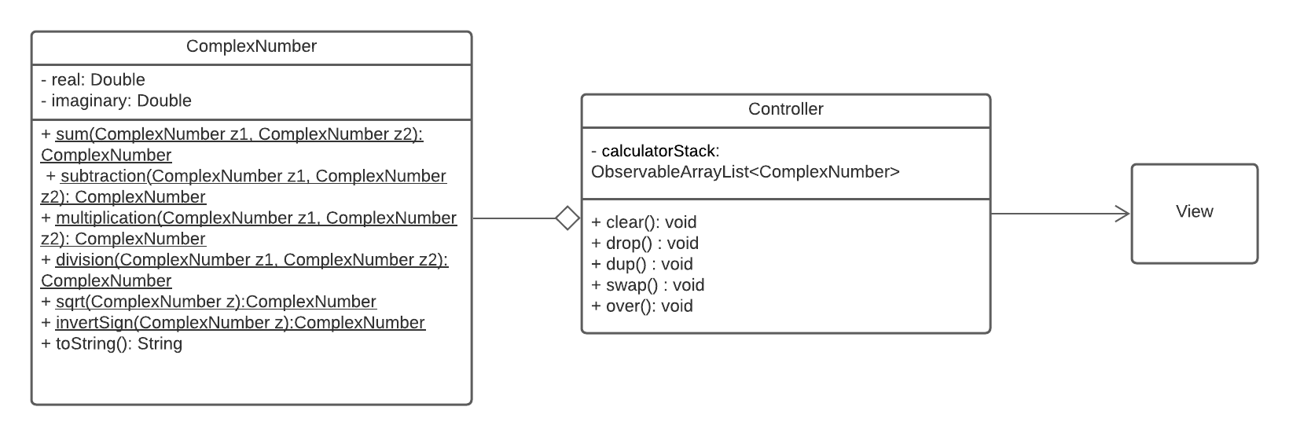

**Description:** This is an UML scheme based on the pattern Model-View-Controller.

**Controller**

Controller maintains a one-way association with View to manage user’s input and perform the right operations on the Model, such as the insertion of a number unto the stack and the execution of the methods defined on ComplexNumber Class.  
It is also responsible for updating the view itself based on the state of the model (e.g. showing the stack’s content).

**ComplexNumber**

The class ComplexNumber represents the Model in the MVC pattern and manages complex numbers represented in Cartesian notation. It provides some functions that allow to make some basics operations between complex numbers. It also provides their Cartesian notation representation.

**View**

View is the graphical view of the entire Application.

**Draft View of the GUI**

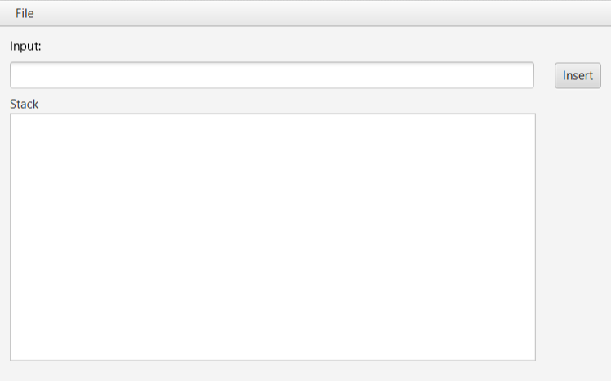

The user is going to insert the input (complex numbers or basic operations) inside the Input TextField. Then he clicks the Insert button, and the number is going to be visualized in the Stack visualization area below. If he inputs an operation the result is going to be visualized in the area below.